Name _______________

Microscope License Test

INSTRUCTIONS: Write your answers on your answer sheet in the blanks corresponding to each question.

(In blanks 1-13 on your answer sheet, label the names of microscope parts 1-13 of the diagram below.)

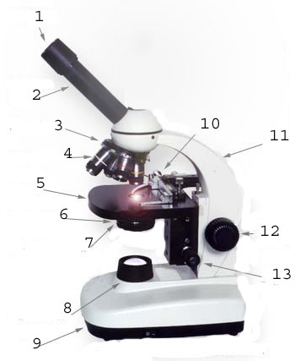

Answer questions 14- 25 below in blanks # 14-25 on your answer sheet.

- The bottom of the microscope, used for support, is called the ___

- When first examining a subject under the microscope, use the ___ power objective first.

- The lens at the top of the microscope, through which you look, is the ___.

- When focusing, use the ___ adjustment knob first.

- A light source, used in place of a mirror, is called the ___.

- The ___ hold the slide in place.

- When carrying the microscope, hold it with two hands by the ___ and the base.

- The ___ varies the amount of light which enters the objective lenses.

- The ___ holds two or more lenses and can be rotated.

- If the eyepiece of a compound microscope has a magnification of 10x, and the objective lens which are using is 40x, the resulting magnification of the specimen is ___.

- True or False: The proper way to use a monocular microscope is to look through the eyepiece with one eye closed tightly.

- When you move your slide to the right, the image you see under the microscope appears to mov

Name _______________

Microscope License Test (KEY)

INSTRUCTIONS: Write your answers on your answer sheet in the blanks corresponding to each question.

(In blanks 1-13 on your answer sheet, label the names of microscope parts 1-13 of the diagram below.)

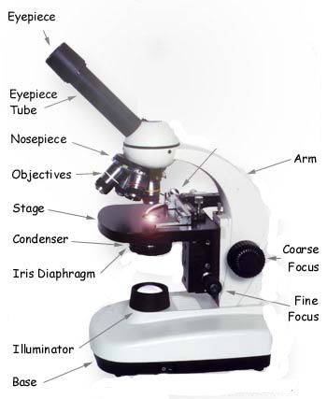

Answer questions 14- 25 below in blanks # 14-25 on your answer sheet.

- The bottom of the microscope, used for support, is called the __BASE_

- When first examining a subject under the microscope, use the __LOW_ power objective first.

- The lens at the top of the microscope, through which you look, is the _EYEPIECE__.

- When focusing, use the _COARSE__ adjustment knob first.

- A light source, used in place of a mirror, is called the _ILLUMINATOR__.

- The __STAGE CLIPS_ hold the slide in place.

- When carrying the microscope, hold it with two hands by the _ARM__ and the base.

- The __DIAPHRAGM_ varies the amount of light which enters the objective lenses.

- The __NOSEPIECE_ holds two or more lenses and can be rotated.

- If the eyepiece of a compound microscope has a magnification of 10x, and the objective lens which are using is 40x, the resulting magnification of the specimen is __400 X_.

- True or False: The proper way to use a monocular microscope is to look through the eyepiece with one eye closed tightly. FALSE

- When you move your slide to the right, the image you see under the microscope appears to move to the __LEFT_.

Name _________________

Answer Sheet for Microscope License Test

1.____________________ 14. ____________________

2.____________________ 15. ____________________

3.____________________ 16.___________________

4.___________________ 17.___________________

5.____________________ 18. ___________________

6.____________________ 19.___________________

7.____________________ 20. ___________________

8.____________________ 21.___________________

9.____________________ 22.___________________

1o.____________________ 23.___________________

11.____________________ 24.___________________

12.____________________ 25. ____________________

13. ___________________

Microscope License

Name __________

Class___________ PHOTO

Date of Birth __ / __ / __

Date Issued __ / __ / __

